**The Mystery of missing Miss Dotty Commers and the D.C. Skybridge:**

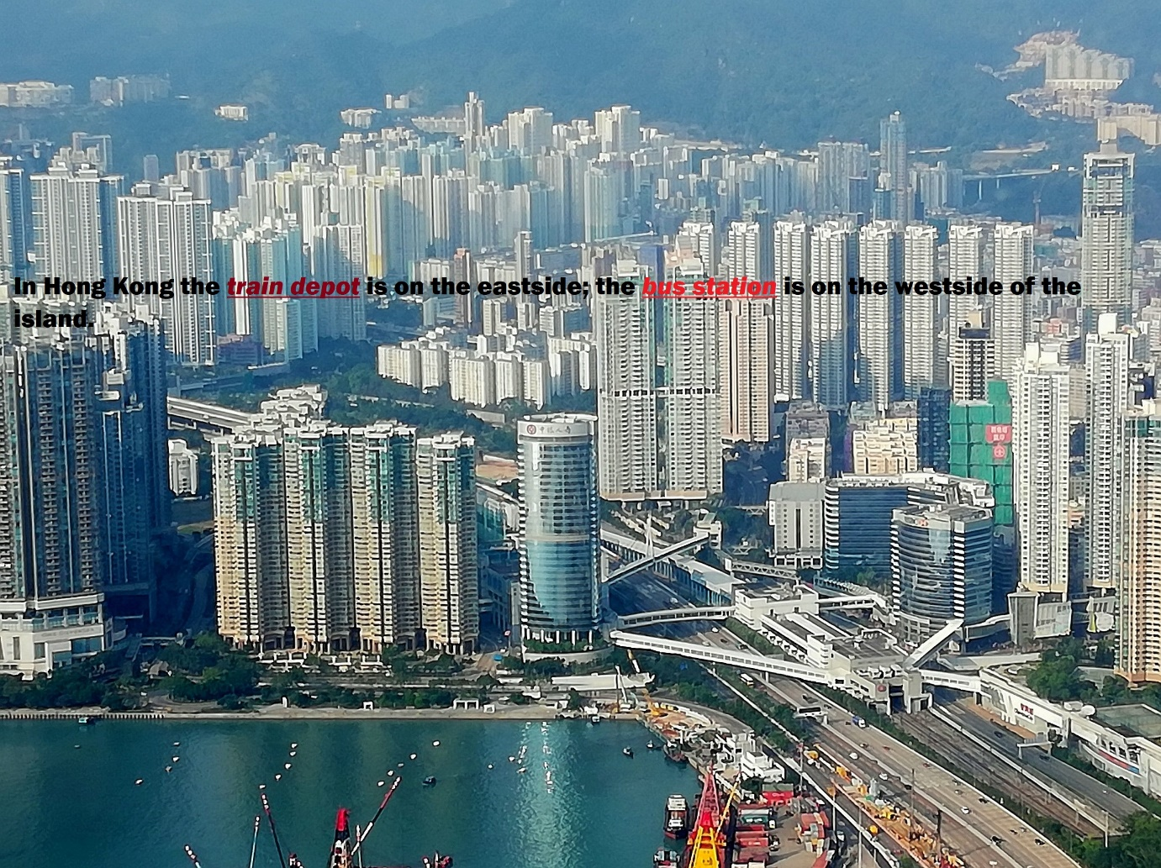

Miss Dotty Commers was a foreign pet doctor**;** the British veterinarian worked exclusively with cats and dogs.

Miss Dotty Commers owned a cat clinic on the eastside**;** on the westside was her dog hospital.

She was so well known that she had a bridge named after her; the D.C. Skybridge stands for Dotty Commers.

One minute she was seen walking on the D.C. Skybridge**;** a minute later she was gone.

Some people think Dotty Commers was kidnapped**;** others think that she vanished into thin air.

*She was so well known that she had a bridge named after her****;*** *the D.C. Skybridge stands for Dotty Commers.* **Or does it?**